NAAN MUDHALVAN ASSIGNMENT DOCUMENT

**COURSE TITLE** : DIGITAL MARKETING

**COLLEGE CODE** 1105

**COLLEGE NAME** : GOJAN SCHOOL OF BUSINESS AND TECHNOLOGY

**NM ID** : 94DA73B195E26D48AE948481DAB51567

**NAME** : SIVAPRAGASAM J

**REGISTER NUMBER** 110520106336

**YEAR** : 4TH YEAR

**DEPARTMENT** : ELECTRONICS AND COMMUNICATION ENGINEERING

1. Create a blog or website using Blogspot and Wordpress. Customize the theme design and post new article with 500 words.

Link <https://crickethub1234.blogspot.com/2023/10/cricket-hub.html>



1. Create a New Facebook Business Page and post one social media poster for your brand.

Link: <https://www.facebook.com/cricket.hub.476022?mibextid=2JQ9oc>

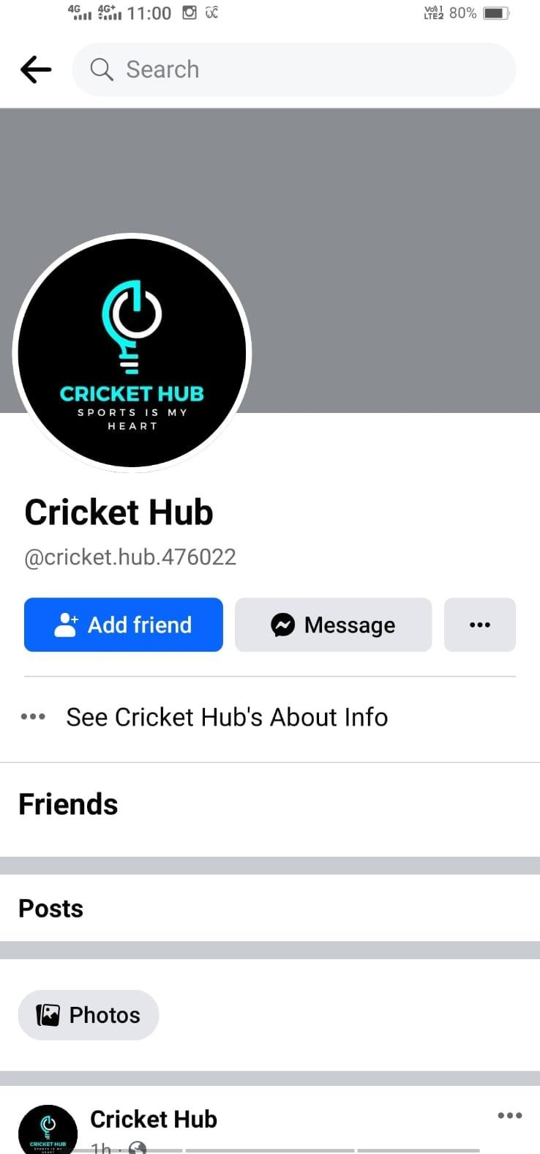

1. Create and design a social media advertisement poster using canva.

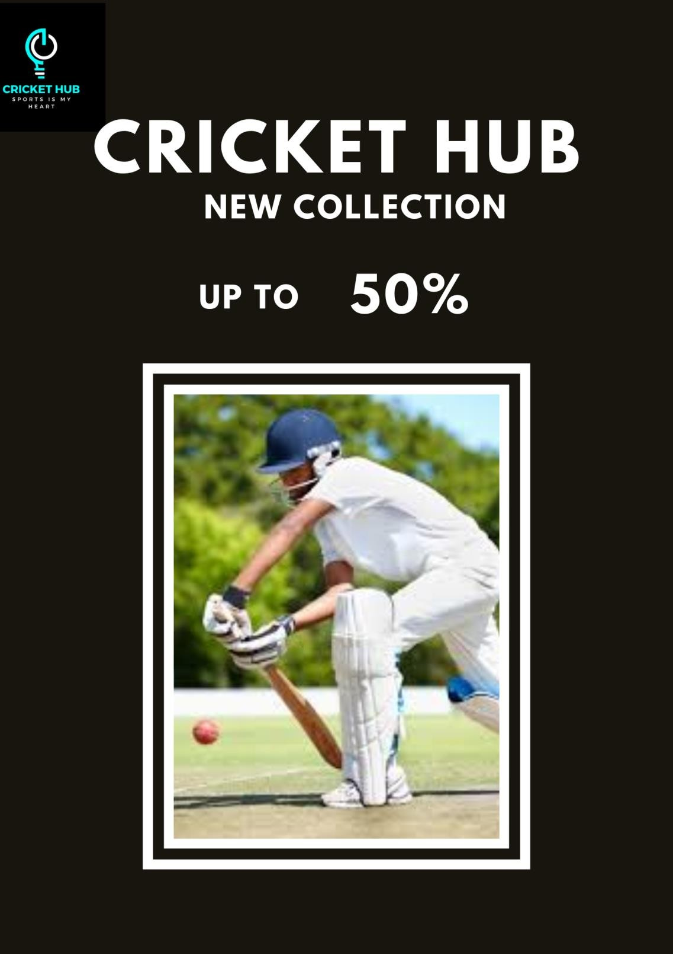

1. Create email newsletter design using MailChimp or canva tool.

Link: [https://www.canva.com/design/DAFx9Ezbq1E/ZIC4Cu65ZQUMxXWMoVxPnw/view?utm_c](https://www.canva.com/design/DAFx9Ezbq1E/ZIC4Cu65ZQUMxXWMoVxPnw/view?utm_content=DAFx9Ezbq1E&utm_campaign=designshare&utm_medium=link&utm_source=editor) [ontent=DAFx9Ezbq1E&utm_campaign=designshare&utm_medium=link&utm_source=editor](https://www.canva.com/design/DAFx9Ezbq1E/ZIC4Cu65ZQUMxXWMoVxPnw/view?utm_content=DAFx9Ezbq1E&utm_campaign=designshare&utm_medium=link&utm_source=editor)

